**Social Media Resources**

Right click on this graphic and save it as a picture.

**Facebook & Instagram Example:**

*Caption:*

Friends – I’m so excited!

I’m hosting an adult Bible Study group at my home on Thursdays at 7:00 pm, starting on March 5! No matter where you land on your perspective of God, I would love to see you there. We’ll be using the Precept Bible Study Method to individually study & discover truth for ourselves. Then we’ll gather together once a week to talk about what we saw.

God’s Word has changed my life, and I can’t wait to start diving deeper with community. Private message me if you’d like to come, and I’ll send you all the information!

Friends – I’m so excited!

I’m hosting a ____________ [if your Bible Study is a particular type of group like

“women’s” or “young adult”, write that here] Bible Study group at _________ [insert general location, not personal address] on _____________, [insert days & times] starting on _________! [insert starting date here] No matter where you land on your perspective of God, I would love to see you there.

We’ll be using the Precept Bible Study Method to individually study & discover truth for ourselves. Then we’ll gather together __________ [insert frequency of group gatherings] to talk about what we saw. [Optional – add a short snippet about the book / study you are doing]

God’s Word has changed my life, and I can’t wait to start diving deeper with community. Private message me if you’d like to come, and I’ll send you all the information!

Additional Image options:

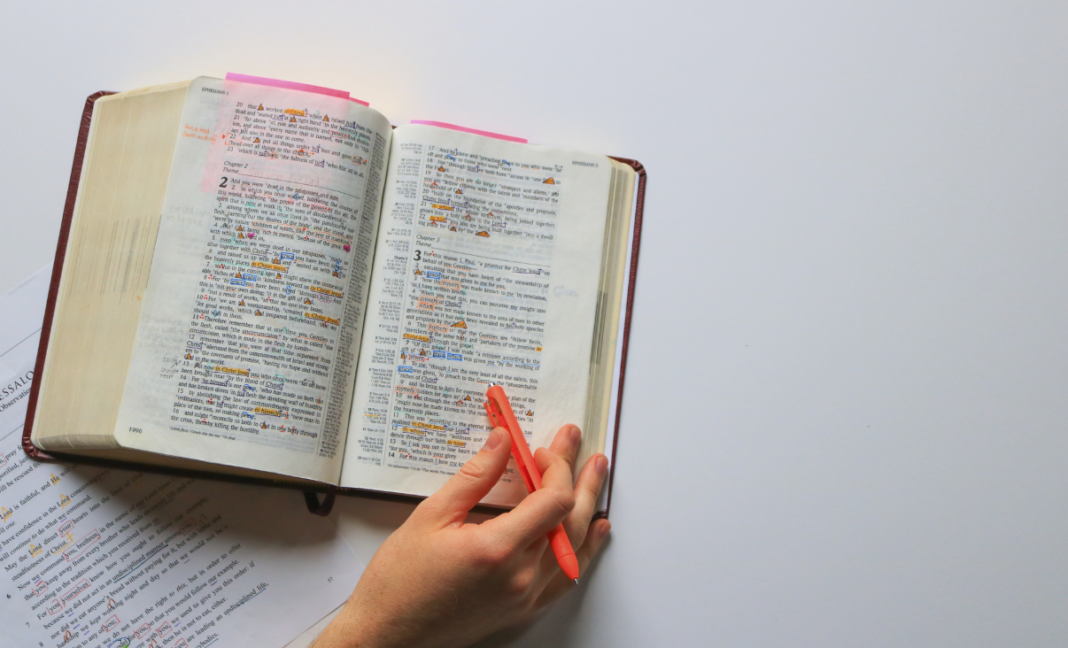

Download:<https://precept.box.com/shared/static/x7sgkw8kf89tn9d7stf7h84fadj4n8by.jpg>

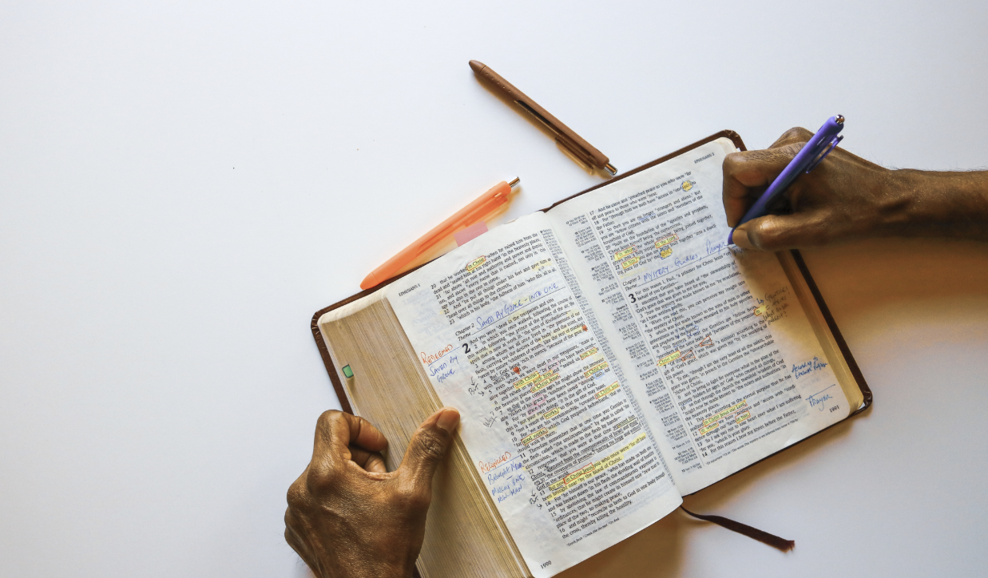

Download: <https://precept.box.com/shared/static/ujb082fagfgy391s2z7ble5pc66bviwd.jpg>



Download: <https://precept.box.com/shared/static/39cekf0d9oxctg5ve281k16n8frmwvcq.jpg>

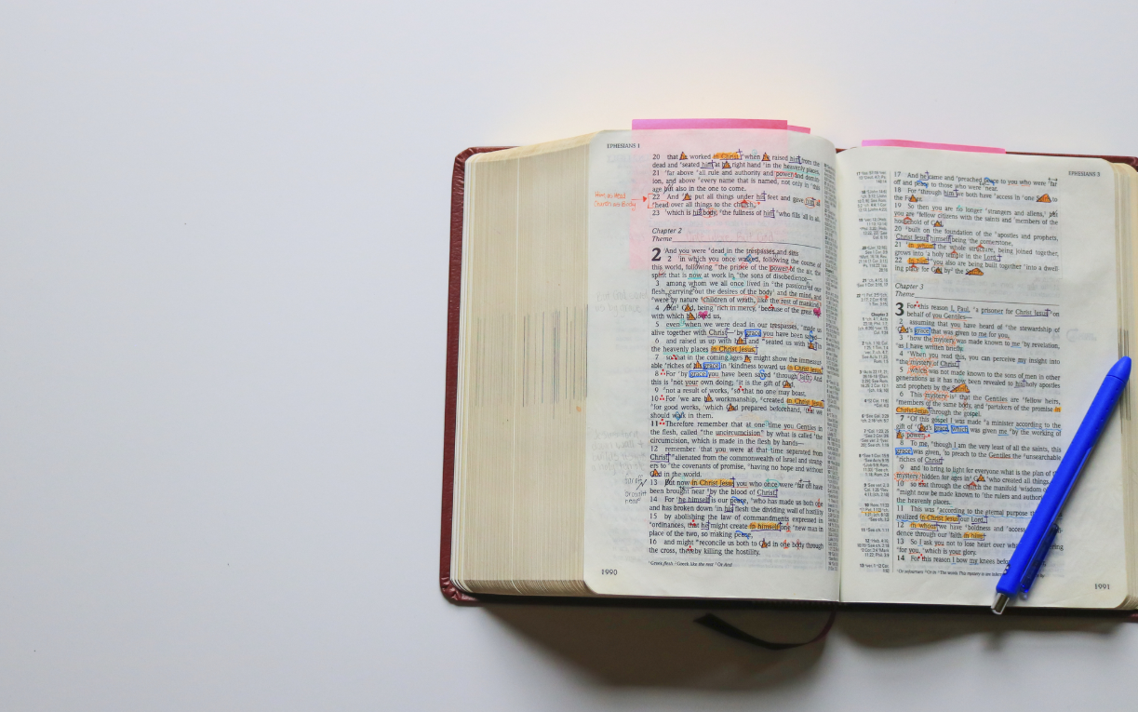

Download: <https://precept.box.com/shared/static/v0lkcb8gu9gg1w7j41r1dqjaj76duuej.jpg>